**QGENERATOR**

**MAJOR PROJECT**

##### SUBMITTED IN PARTIAL FULFILLMENT OF

***THE REQUIREMENTS FOR THE AWARD OF THE DEGREE OF***

#### BACHELOR OF TECHNOLOGY

**(COMPUTER SCIENCE & ENGINEERING)**

**SUBMITTED BY**

**SANYAM JAIN (1512023)**

Under the Guidance of

Ms. Renuka



## Department of Computer Science & Engineering

**N. C. College of Engineering,**

**Israna – 132107 (Panipat)**

**KURUKSHETRA UNIVERSITY**

**KURUKSHETRA, INDIA**

**MAY-2016**

# Acknowledgement

I truly acknowledge the cooperation and help made by **Ms. Renuka (Infosys)** and **Mrs. Bhawna Gupta** Department of Computer Science and Engineering, N.C. College of Engineering, Israna, Panipat, Kurukshetra University. They have been a constant source of guidance throughout the course of this project. I would also like to thank for their help and guidance in understanding **QGenerator**. I am also thankful to my friends and family whose silent support led me to complete my project.

(*Signature*)

Sanyam Jain (1512023)

Section - CO2



**N.C. College of Engineering, Israna-132107**

(An Autonomous College)

*Approved by AICTE, Govt. of India, Dept. of Technical Education, Haryana, Accredited by NBA and ISO-9001 Certified.*

**Phone: 0180-2579835, 2579764, 3252064 Email:info@ncce.edu**

**CERTIFICATE**

This is to certify that the project entitled ”**QGenerator**” is a bona fide work carried out by Mr. Sanyam Jain having roll number 1512023 under my guidance and supervision and submitted in partial fulfillment of B.Tech degree in Computer Science & Engineering of Kurukshetra University, Kurukshetra. The work embodied in this project has not been submitted for any other degree or diploma.

**Mrs. Bhawna Gupta**

Associate Professor & Head,

Department of Computer Science & Engineering

N.C.C.E, Israna, Panipat

**TABLE OF CONTENTS**

1. BUSINESS OF THE CUSTOMER 5

2. PROJECT/PRODUCT OVERVIEW 5

2.1 USE CASE DIAGRAM 5

3. FUNCTIONAL REQUIREMENTS 6

3.1 REQUIREMENTS IN SCOPE 6

3.2 REQUIREMENTS OUT OF SCOPE **Error! Bookmark not defined.**

3.3 USER INTERFACE 7

4. NON FUNCTIONAL REQUIREMENTS 7

4.1 Security: Login ID and Password for all user 7

4.2 Audit Trail: Log records **Error! Bookmark not defined.**

4.3 Error logging: Log records **Error! Bookmark not defined.**

4.4 Multi language Support: NA 7

4.5 Performance: NA 7

4.6 Scalability: Expected for a maximum of 1000 users 7

4.7 Availability / reliability: 24/7 7

4.8 Data migration: NA **Error! Bookmark not defined.**

4.9 Data Retention: NA **Error! Bookmark not defined.**

4.10 Legal/ regulatory requirements: NA **Error! Bookmark not defined.**

5. HARDWARE AND SOFTWARE REQUIREMENTS 7

5.1 Deployment Environment Requirements 7

5.2 Development Environment Requirements 7

6. USE CASE DIAGRAM……………………………………………………………………………………………………………………….8

6.1 Overall use case diagram……………………………………………………………………………………………………….9

6.2 Use case diagram of Admin…………………………………………………………………………............................9

6.3 Use case diagram of course owner…………………………………………………………………………………………9

7. DATABASE DESIGN……………………………………………………………………………………………………………………….11

8. UNIT TEST PLAN….……………………………………………………………………………………………………………………….12

8. SCREENSHOTS OF PROJECT……………………………………………………………………….....................................24

# BUSINESS OF THE CUSTOMER

Quiz is a form of game in which the players attempt to answer questions correctly. It helps individual to enhance information at the same time to have fun. QGenerator is an online quiz tool, for building and testing knowledge of users.

# PROJECT/PRODUCT OVERVIEW

QGenerator is a web-based application for all those users who want to create a quiz and want to test their knowledge by taking quiz. Admin of this application should be able to add/modify/delete courses and provide authority to the course owner. Course owner can add/delete/modify topics under that course. And can add/modify/delete questions under that topic. Course owner can schedule a quiz for a set of people or users of that application. User can take quiz and can see the score immediately. Course owner should be able to see the reports related to their courses.

## USE CASE DIAGRAM

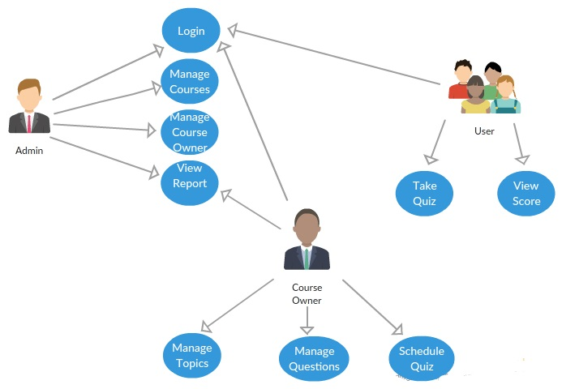

# FUNCTIONAL REQUIREMENTS

## REQUIREMENTS IN SCOPE

The project scope will include:

* The application must allow it’s user to sign in
* Three types of users:
  + Admin: Manage courses and course owners and view report
  + Course Owner: Manage topics, Manage questions, Schedule quiz and view report
  + User: Take quiz and view score
* **Admin:**
  + Manage Courses: Admin should be able to add/update/delete courses
  + Manage Course Owners: Admin should be able to add/update/delete course owner for a course from a specific date
  + View Report: Admin should be able to view a report of current course owners for all the course
  + Admin should be able to generate password for Course owners to login
* **Course Owner**
  + Manage Topics: Course owner should be able to:
    - Add/update/delete topics under authorized course
    - Specify total score for the topic and no of questions to be picked from the topic for a quiz
  + Manage Questions: Course owner should be able to:
    - Add/update/delete questions under a topic of authorized course
    - Specify the type of question. A question can be of multiple choice/multiple response (radio button or check boxes based)
    - Add an image as a part of question or part of choice/options
    - Specify correct answer for the question
  + Schedule Quiz: Course owner should be able to:
    - Schedule a quiz for a set of users. User IDs can be added for a scheduled quiz
    - Choose type of Quiz. Quiz can be with or without time. If a quiz is timer based, specify the time
    - Schedule quiz for future date or current date only
  + View Report: Course owner should be able to:
    - View report of any scheduled quiz to know the result of users appeared in the quiz. A graphical chart based report to display number of users failed or passed
    - View report of scheduled quizzes
    - View number of questions per topic and total number of questions in the course
    - Download all the reports
  + Generate a password for each scheduled quiz
* **User**
  + Take Quiz: User should be able to:
    - Login to the application using provided password
    - Take quiz only at scheduled date and time
    - View only one question in the screen at a time
    - Navigate to next and previous questions
    - Submit the quiz
  + View Score: User should be able to
    - View score after submitting the quiz
    - View score for timer based quiz as well. It should auto submit if time is over
  + Disable clipboard: User should not be able to copy any questions

## USER INTERFACE

* The UI is simple and easy to understand
* The UI adapts to different screen sizes and resolutions

# NON FUNCTIONAL REQUIREMENTS

## Security: Login ID and Password for all user

## Multi language Support: NA

## Performance: NA

## Scalability: Expected for a maximum of 1000 users

## Availability / reliability: 24/7

# HARDWARE AND SOFTWARE REQUIREMENTS

## Deployment Environment Requirements

**Hardware requirements**

Processor/RAM/HDD : 2GB RAM/above4HDD/Intel Core Processor

Web server : Windows 7

Database Server : SQL Server 2008 or above

**Software requirements**

OS for Web server : Windows 7

OS for Database Server : Windows 7

DBMS : SQL Server 2008 or above

## Development Environment Requirements

IDE : Visual Studio 2010 or above

Processor/RAM/HDD : Intel Core Processor /2GB RAM / 4 GB HDD

**6. USE CASE DOCUMENT**

**6.1 Overall use case diagram**



**6.2 Use Case Description ( for Admin)**



**6.3 Use Case Description (for Course Owner)**



**6.4 Use Case Description ( for Registered User)**



# DATABASE DESIGN

# 

8. UNIT TEST PLAN

# 1. Test Environment

## 1.1 Hardware

**Processor/RAM/HDD**  : 2GB RAM/above4HDD/Intel Core Processor

**Web server**  : Windows 7

**Database Server**  : SQL Server 2008 or above

## 1.2 Software

**OS for Web server** : Windows 7

**OS for Database Server**  : Windows 7

**DBMS**  : SQL Server 2008 or above

**Third Party S/Ws** : NA

# 3. Unit Test Report

**Author :** Richa

Sahil Mahna

Sanyam Jain

Sarthak Miglani

Soumen

Tarkash Bhatla

1. **Program Name :** QGenerator
2. **Functionality Tested :** Modular Functionalities and Validations
3. **Test Conditions :**

|  |  |  |  |  |  |  |
| --- | --- | --- | --- | --- | --- | --- |
| **Sl: No:** | **Condition to be tested** | **Expected Result** | **Test Cycle** | | | |
|  |  |  | S | 1 | 2 | 3 |
| **ROLE: Admin/Course Owner/Registered User**  **MODULE: Login** | | | | | | |
| 1 | Enter valid credentials (Username and Password) and press Login button. | Redirect to the corresponding Home page. | 2 | Fail | Pass | Pass |
| 2 | Enter invalid username and press Login button. | Show corresponding error message and stay on the Login page. | 1 | Pass | Pass | Pass |
| **ROLE: Admin**  **MODULE: Register Admin** | | | | | | |
| 1 | Enter valid Admin details and click on Register button. | Show success message and redirect to Admin Home page. | 2 | Fail | Pass | Pass |
| 2 | Enter invalid Admin details and click on Add button. | Show error message and stay on the Register Admin page. | 2 | Pass | Pass | Pass |
| 3 | Validation of UserName | User Name should consist of a minimum of 4 characters, maximum 20 characters and User Name should not be null. | 1 | Pass | Pass | Pass |
| 4 | Validation of Password | The length of the Password contains a minimum 6, maximum 15 characters and password is not null | 1 | Pass | Pass | Pass |
| **ROLE: Admin**  **MODULE: Add Course** | | | | | | |
| 1 | Enter valid Course details and click on Add button. | Show success message and redirect to Manage Courses page. | 1 | Pass | Pass | Pass |
| 2 | Enter invalid Course details and click on Add button. | Show error message and stay on the Add Course page. | 2 | Fail | Pass | Pass |
| 3 | Validation of Course Name | Course Name consists of a minimum of 4 characters and maximum 20 characters and Course Name is not null | 1 | Pass | Pass | Pass |
| **ROLE: Admin**  **MODULE: Manage Courses** | | | | | | |
| 1 | Select a Course and click on Delete button. | Show success/error message and redirect to Manage Courses page. | 2 | Fail | Pass | Pass |
| 2 | Select a Course and click on Update button. | Redirect to Update Course page. | 4 | Fail | Fail | Pass |
| **ROLE: Admin**  **MODULE: Update Course** | | | | | | |
| 1 | Enter valid Course details and click on Update button. | Show success message and redirect to Manage Courses page. | 3 | Fail | Pass | Pass |
| 2 | Enter invalid Course details and click on Update button. | Show error message and stay on the Update Courses page. | 2 | Fail | Pass | Pass |
| 3 | Validation of Course Name | Course Name consists of a minimum of 4 characters and maximum 20 characters and Course Name is not null | 1 | Pass | Pass | Pass |
| **ROLE: Admin**  **MODULE: Add Course Owner** | | | | | | |
| 1 | Enter valid Course Owner details and click on Add button. | Show success message and redirect to Manage Course Owners page. | 2 | Pass | Pass | Pass |
| 2 | Enter invalid Course Owner details and click on Add button. | Show error message and stay on the Add Course Owner page. | 3 | Fail | Pass | Pass |
| 3 | Validation of Name | Name consists of a minimum of 4 characters and maximum 30 characters and Name is not null. | 1 | Pass | Pass | Pass |
| 4 | Validation of UserName | User Name should consist of a minimum of 4 characters, maximum 20 characters and User Name should not be null. | 1 | Pass | Pass | Pass |
| 5 | Validation of Password | The length of the Password contains a minimum 6, maximum 15 characters and password is not null | 1 | Pass | Pass | Pass |
| 6 | Validation of DepartmentId | DepartmentId is valid i.e, it exists in the ‘Department’ table and is not null | 1 | Pass | Pass | Pass |
| 7 | Validation of CourseId | CourseId is valid i.e, it exists in the ‘Course’ table and is not null | 1 | Pass | Pass | Pass |
| 8 | Validation of Mobile Number | The length of the Mobile Number is 10 and Mobile Number is not null | 1 | Pass | Pass | Pass |
| **ROLE: Admin**  **MODULE: Manage Course Owners** | | | | | | |
| 1 | Select a Course Owner and click on Delete button. | Ask for confirmation and show success/error message and redirect to Manage Course Owners page. | 3 | Fail | Pass | Pass |
| 2 | Select a Course Owner and click on Update button. | Redirect to Update Course Owner page. | 4 | Fail | Fail | Pass |
| 3 | View exam results | Shows the no of students passed or failed of that particular course | 2 | Pass | Pass | Pass |
| **ROLE: Admin**  **MODULE: Update Course Owner** | | | | | | |
| 1 | Enter valid Course Owner details and click on Update button. | Show success message and redirect to Manage Course Owners page. | 2 | Pass | Pass | Pass |
| 2 | Enter invalid Course Owner details and click on Update button. | Show error message and stay on the Update Course Owner page. | 3 | Fail | Pass | Pass |
| 3 | Validation of Name | Name consists of a minimum of 4 characters and maximum 20 characters and Name is not null. | 1 | Pass | Pass | Pass |
| 4 | Validation of UserName | User Name should consist of a minimum of 4 characters, maximum 20 characters and User Name should not be null. | 1 | Pass | Pass | Pass |
| 5 | Validation of Password | The length of the Password contains a minimum 6, maximum 15 characters and password is not null | 1 | Pass | Pass | Pass |
| 6 | Validation of DepartmentId | DepartmentId is valid i.e, it exists in the ‘Department’ table and is not null | 1 | Pass | Pass | Pass |
| 7 | Validation of CourseId | CourseId is valid i.e, it exists in the ‘Course’ table and is not null | 1 | Pass | Pass | Pass |
| 8 | Validation of Mobile Number | The length of the Mobile Number is 10 and Mobile Number is not null | 1 | Pass | Pass | Pass |
| 9 | Validation of EmailId | EmailId contains minimum of 4 and maximum of 40 characters and EmailId is not null | 1 | Pass | Pass | Pass |
| 10 | Validation of Date of Joining | Date of joining should be less than the current date | 1 | Pass | Pass | Pass |
| **ROLE: Course Owner**  **MODULE: Manage Topics** | | | | | | |
| 1 | Select a Topic and click on Delete button. | Show success/error message and redirect to Manage Topics page. | 3 | Fail | Pass | Pass |
| 2 | Select a Topic and click on Update button. | Redirect to Update Topic page. | 3 | Fail | Pass | Pass |
| **ROLE: Course Owner**  **MODULE: Add Topic** | | | | | | |
| 1 | Enter valid Topic name and click on Add button. | Show success message and redirect to Manage Topics page. | 1 | Pass | Pass | Pass |
| 2 | Enter invalid Topic details and click on Add button. | Show error message and stay on the Add Topic page. | 2 | Pass | Pass | Pass |
| 3 | Validation of Topic Name | Topic Name consists of a minimum of 4 characters and maximum 20 characters and Topic Name is not null | 1 | Pass | Pass | Pass |
| 4 | Validation of CourseId | CourseId is valid i.e, it exists in the ‘Course’ table and is not null | 1 | Pass | Pass | Pass |
| **ROLE: Course Owner**  **MODULE: Update Topic** | | | | | | |
| 1 | Enter valid Topic details and click on Update button. | Show success message and redirect to Manage Topics page. | 2 | Pass | Pass | Pass |
| 2 | Enter invalid Topic details and click on Update button. | Show error message and stay on the Update Topic page. | 2 | Pass | Pass | Pass |
| 3 | Validation of Topic Name | Topic Name consists of a minimum of 4 characters and maximum 20 characters and Topic Name is not null | 1 | Pass | Pass | Pass |
| 4 | Validation of CourseId | CourseId is valid i.e, it exists in the ‘Course’ table and is not null | 1 | Pass | Pass | Pass |
| **ROLE: Course Owner**  **MODULE: Manage Questions under a Topic** | | | | | | |
| 1 | Select a Question and click on Delete button. | Show success/error message and redirect to Manage Questions under a Topic page. | 3 | Fail | Pass | Pass |
| 2 | Select a Question and click on Update button. | Redirect to Update Question page. | 4 | Fail | Fail | Pass |
| **ROLE: Course Owner**  **MODULE: Add Questions under a Topic** | | | | | | |
| 1 | Enter valid Question details and click on Add button. | Show success message and redirect to Manage Questions under a Topic page. | 2 | Pass | Pass | Pass |
| 2 | Enter invalid Question details and click on Add button. | Show error message and stay on the Add Questions under a Topic page. | 2 | Pass | Pass | Pass |
| 3 | Validation of Problem Statement | Problem Statement is not null | 1 | Pass | Pass | Pass |
| 4 | Validation of QuestionType | QuestionType is either “Radio” or “CheckBox” | 1 | Pass | Pass | Pass |
| 5 | Validation of Answer1 | Answer1 is not null | 1 | Pass | Pass | Pass |
| 6 | Validation of Answer2 | Answer2 is not null | 1 | Pass | Pass | Pass |
| 7 | Validation of Answer3 | Answer3 is not null | 1 | Pass | Pass | Pass |
| 8 | Validation of Answer4 | Answer4 is not null | 1 | Pass | Pass | Pass |
| 9 | Validation of Correct Answer | Correct Answer is not null | 1 | Pass | Pass | Pass |
| 10 | Validation of Marks | Marks is not null | 1 | Pass | Pass | Pass |
| 11 | Validation of Topic Id | Topic Id is valid i.e, Topic Id exists in the ‘Topic’ table | 1 | Pass | Pass | Pass |
| **ROLE: Course Owner**  **MODULE: Update Question under a Topic** | | | | | | |
| 1 | Enter valid Question details and click on Update button. | Show success message and redirect to Manage Questions under a Topic page. | 5 | Fail | Fail | Pass |
| 2 | Enter invalid Question details and click on Update button. | Show error message and stay on the Update Questions under a Topic page. | 5 | Fail | Fail | Pass |
| 3 | Validation of Problem Statement | Problem Statement is not null | 1 | Pass | Pass | Pass |
| 4 | Validation of QuestionType | QuestionType is either “Radio” or “CheckBox” | 1 | Pass | Pass | Pass |
| 5 | Validation of Answer1 | Answer1 is not null | 1 | Pass | Pass | Pass |
| 6 | Validation of Answer2 | Answer2 is not null | 1 | Pass | Pass | Pass |
| 7 | Validation of Answer3 | Answer3 is not null | 1 | Pass | Pass | Pass |
| 8 | Validation of Answer4 | Answer4 is not null | 1 | Pass | Pass | Pass |
| 9 | Validation of Correct Answer | Correct Answer is not null | 1 | Pass | Pass | Pass |
| 10 | Validation of Marks | Marks is not null | 1 | Pass | Pass | Pass |
| 11 | Validation of Topic Id | Topic Id is valid i.e, Topic Id exists in the ‘Topic’ table | 1 | Pass | Pass | Pass |
| **ROLE: Course Owner**  **MODULE: Schedule Quiz** | | | | | | |
| 1 | Enter valid scheduling details and click on Schedule button. | Show success message and redirect to Manage Quizzes page. | 5 | Fail | Fail | Pass |
| 2 | Enter invalid scheduling details and click on Schedule button. | Show error message and stay on the Schedule Quiz page. | 3 | Fail | Pass | Pass |
| 3 | Validation of CourseId | CourseId should be a valid existing CourseId. | 1 | Pass | Pass | Pass |
| 4 | Validation of Password | The length of the Password contains a minimum 6, maximum 15 characters and password is not null | 1 | Pass | Pass | Pass |
| 5 | Validation of ExamId | ExamId should be a valid existing ExamId. | 1 | Pass | Pass | Pass |
| 6 | Validation of StartTime | StartTime should be a valid time in 24 hours format. | 1 | Pass | Pass | Pass |
| 7 | Validation of QuizType | QuizType should be of Timer or Nontimer type. | 1 | Pass | Pass | Pass |
| **ROLE: Course Owner**  **MODULE: Manage Quizzes** | | | | | | |
| 1 | Select a Quiz and click on edit or delete button | Show success/error message and redirect to Manage Quizzes page. | 4 | Fail | Fail | Pass |
| 2 | Select a Quiz and click on Re-Schedule button. | Redirect to Re-Schedule page. | 4 | Fail | Fail | Pass |
| **ROLE: Course Owner**  **MODULE: Re-Schedule Quizzes** | | | | | | |
| 1 | Enter valid re-scheduling details and click on Re-Schedule button. | Show success message and redirect to Manage Quizzes page. | 3 | Fail | Pass | Pass |
| 2 | Enter invalid re-scheduling details and click on Re-Schedule button. | Show error message and stay on the Re-Schedule Quiz page. | 3 | Fail | Pass | Pass |
| 3 | Validation of CourseId | CourseId should be a valid existing CourseId. | 1 | Pass | Pass | Pass |
| 4 | Validation of Password | The length of the Password contains a minimum 6, maximum 15 characters and password is not null | 1 | Pass | Pass | Pass |
| 5 | Validation of ExamId | ExamId should be a valid existing ExamId. | 1 | Pass | Pass | Pass |
| 6 | Validation of StartTime | StartTime should be a valid time in 24 hours format. | 1 | Pass | Pass | Pass |
| 7 | Validation of QuizType | QuizType should be of Timer or Nontimer type. | 1 | Pass | Pass | Pass |
| **ROLE: Course Owner**  **MODULE: View Report** | | | | | | |
| 1 | Select a quiz under View Quiz Report and click on Generate Report button. | Generate the report showing results of participants of the selected quiz. | 4 | Fail | Fail | Pass |
| 2 | View Scheduled Quizzes | Show the details of all quizzes. | 2 | Pass | Pass | Pass |
| 3 | View Questions | Show the number of questions per topic and the number of questions per course. | 5 | Fail | Fail | Pass |
| 4 | Click on Download Report button. | Generate and start downloading the corresponding report. | 3 | Fail | Pass | Pass |
| **ROLE: Un-Registered User**  **MODULE: Register User** | | | | | | |
| 1 | Enter valid User details and click on Register button. | Show success message and redirect to User Home page. | 1 | Pass | Pass | Pass |
| 2 | Enter invalid User details and click on Add button. | Show error message and stay on the Register User page. | 1 | Pass | Pass | Pass |
| 3 | Validation of Name | Name consists of a minimum of 4 characters and maximum 20 characters and Name is not null | 1 | Pass | Pass | Pass |
| 4 | Validation of User Name | User Name consists of a minimum of 4 characters and maximum 20 characters and User Name is not null | 1 | Pass | Pass | Pass |
| 5 | Validation of Password | Length of the Password contains a minimum 6 and maximum 15 characters and password is not null | 1 | Pass | Pass | Pass |
| 6 | Validation of Mobile Number | Length of the Mobile Number is 10 and Mobile Number is not null | 1 | Pass | Pass | Pass |
| 7 | Validation of Date Of Birth | Date Of Birth is less than or equal to the current date and is not null | 1 | Pass | Pass | Pass |
| **ROLE: Registered User**  **MODULE: Take Quiz** | | | | | | |
| 1 | Enter the valid Quiz details and click on Take Test. | Redirect to the Quiz page and start the quiz if quiz is scheduled. | 3 | Fail | Pass | Pass |
| 2 | Enter the invalid Quiz details and click on Take Test. | Show the error message and stay on the Take Quiz page. | 3 | Fail | Pass | Pass |
| 3 | Validation of QuizId | QuizId should be existing scheduled quiz. | 1 | Pass | Pass | Pass |
| 4 | Validation of Password | Password should match to the quiz password. | 1 | Pass | Pass | Pass |
| **ROLE: Registered User**  **MODULE: View Score** | | | | | | |
| 1 | Taking quiz and clicking on the Submit Answers button. | Scores will be generated as a result of the participant for that particular quiz and will be displayed. | 4 | Fail | Fail | Pass |
| 2 | Taking timer based quiz and after auto-submission of the answers after completion of quiz duration. | Scores will be generated as a result of the participant for that particular quiz and will be displayed. | 7 | Fail | Fail | Fail |

# Screenshots

**9.1 Home Page**

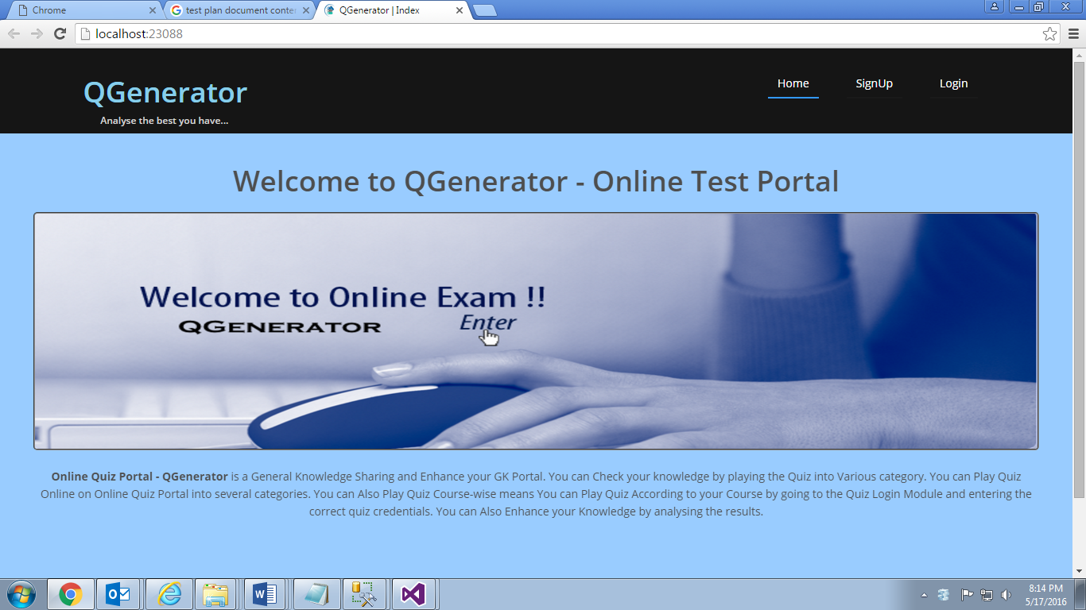

**9.2 Login for registered user**

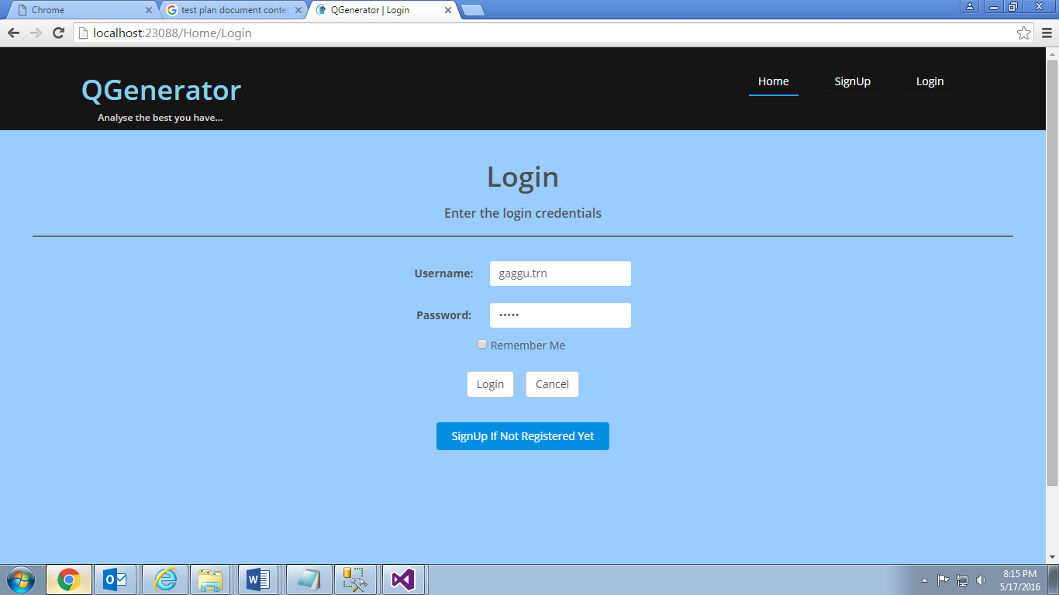

**9.3 User Dashboard**

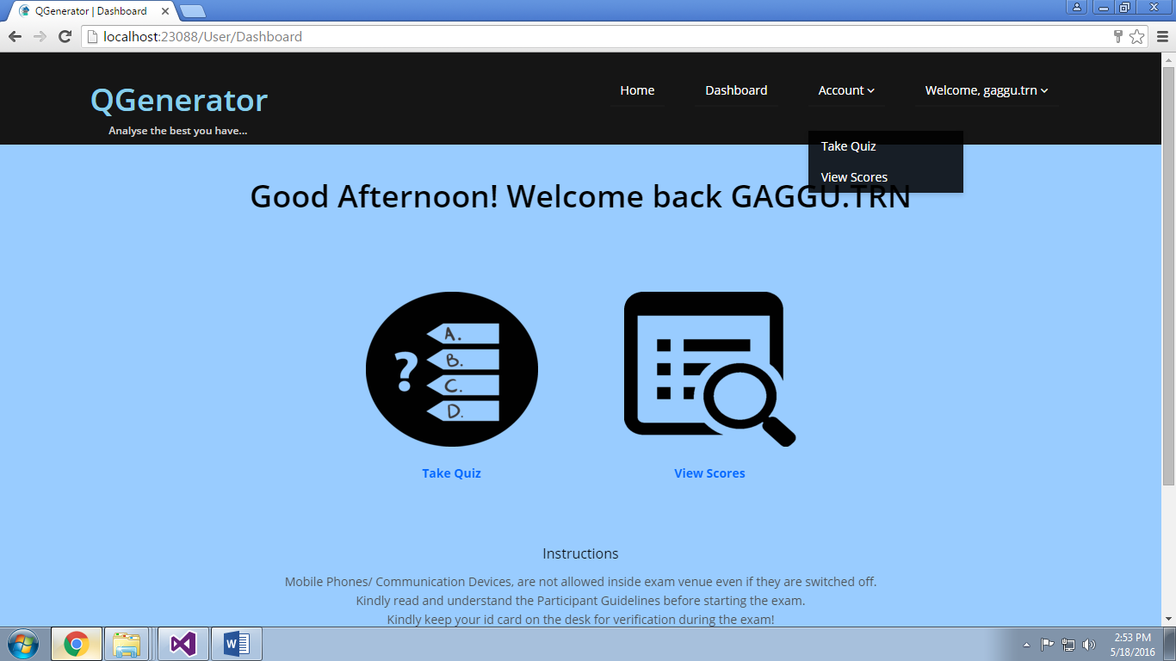

**9.4 Quiz Login Page**

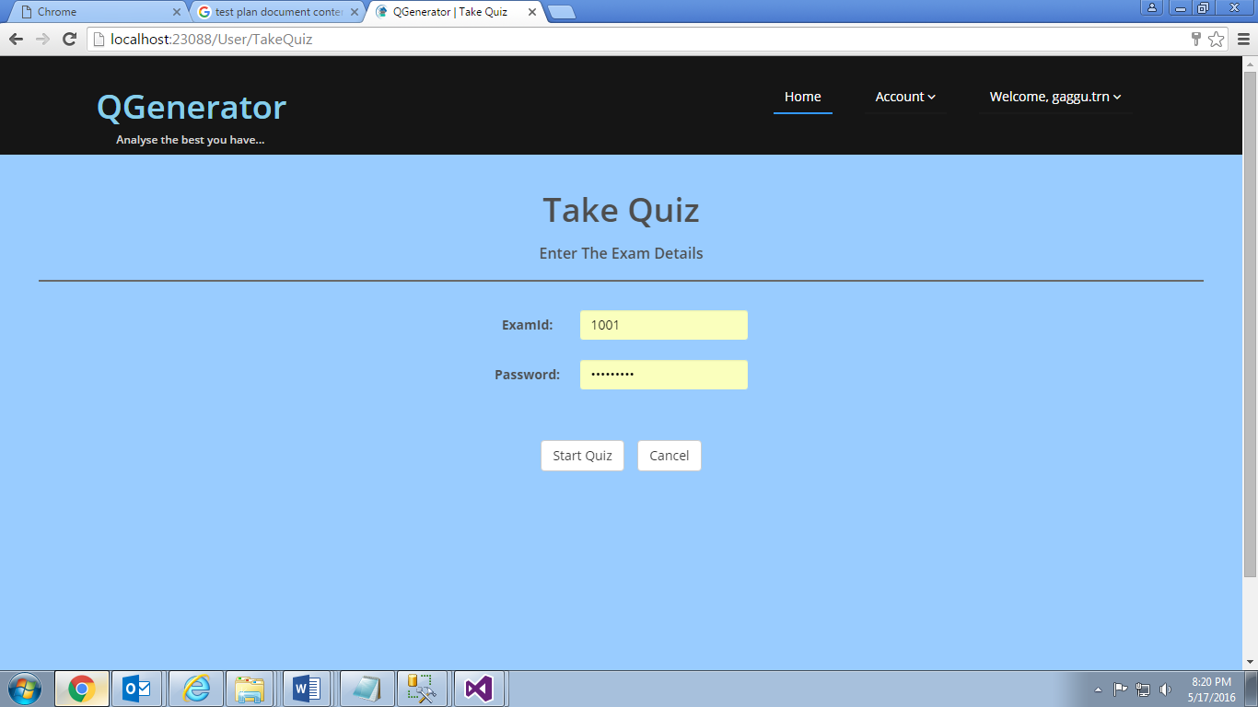

**9.5 Online Exam**

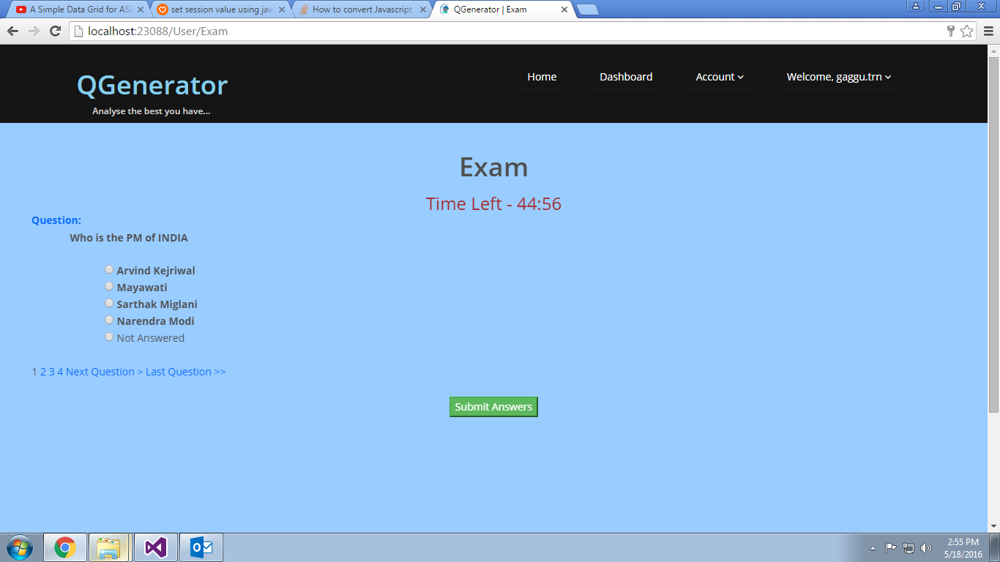

**9.6 Exam question with Image.**

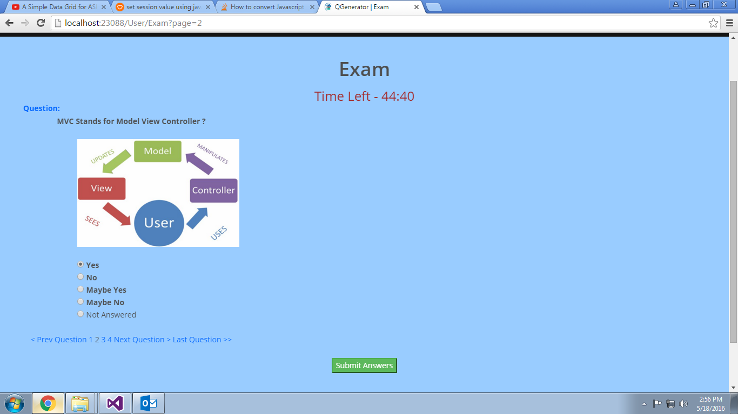

**9.7 Quiz Result**

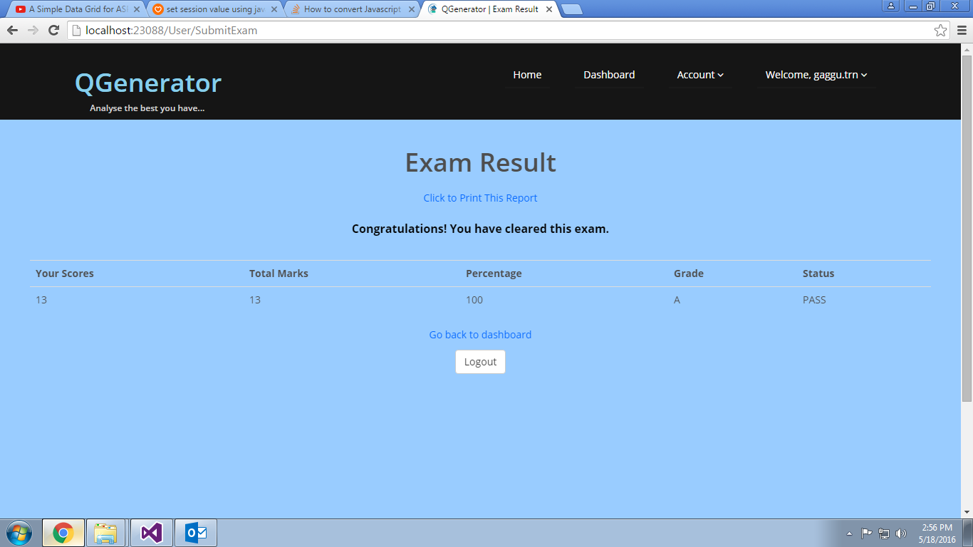

**9.8 User Performance report**

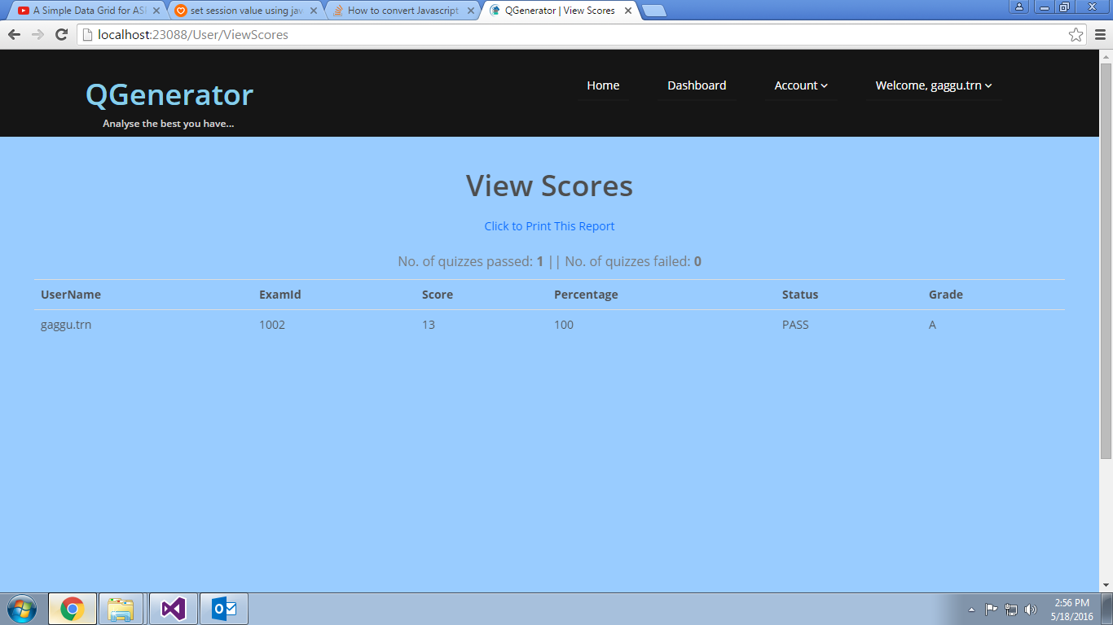

**9.9 Register a User (Sign Up)**

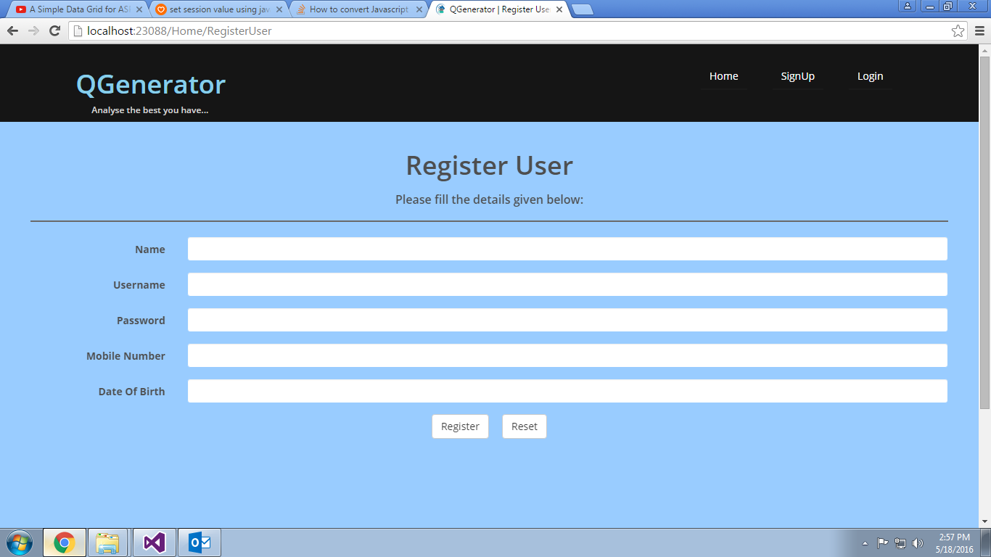

**9.10 Login for Admin and course owner**

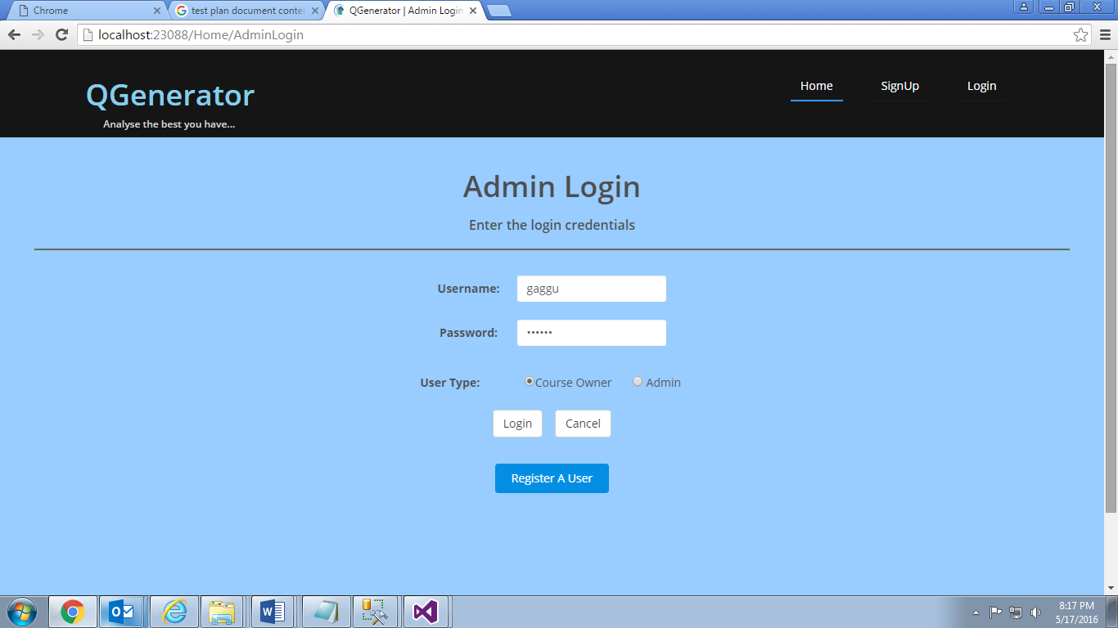

**9.11 Admin Welcome page**

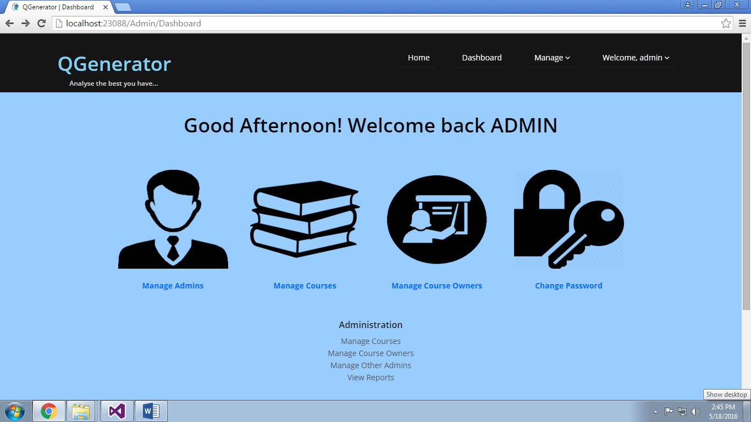

**9.12 Operation Menu of admin**

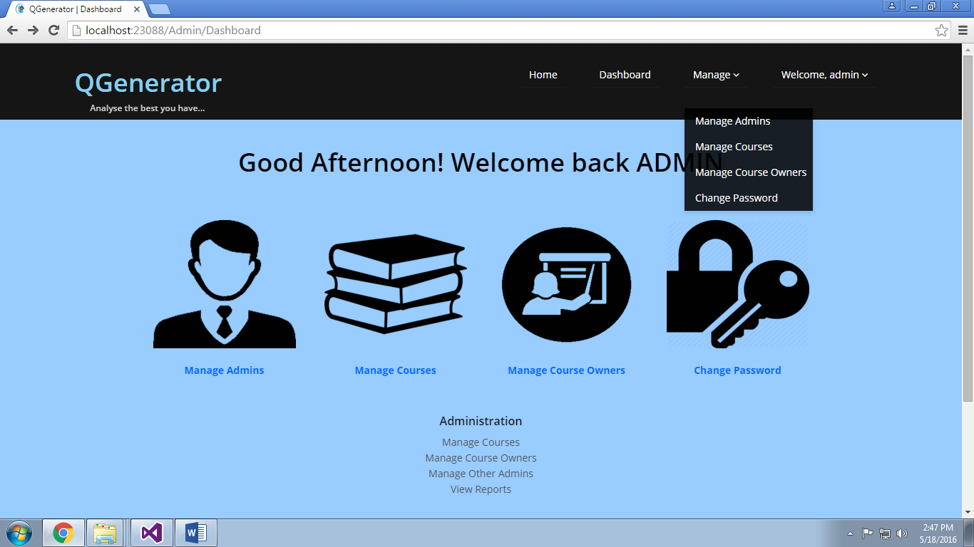

**9.13 Management of other Admins**

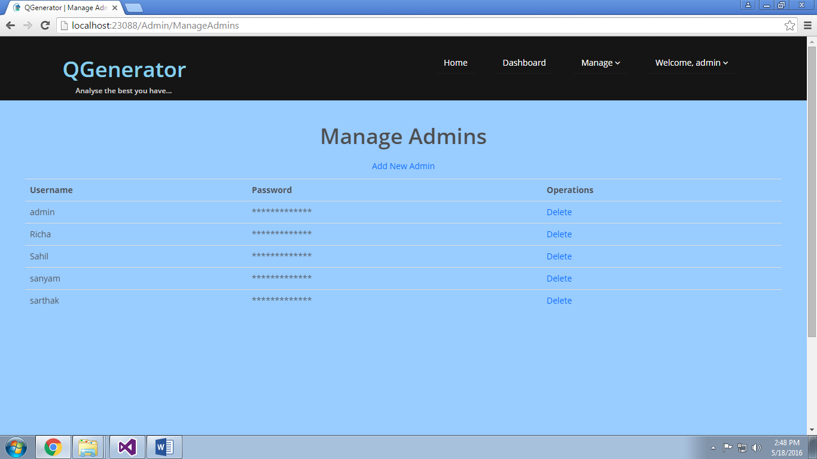

**9.14 Manage Courses**

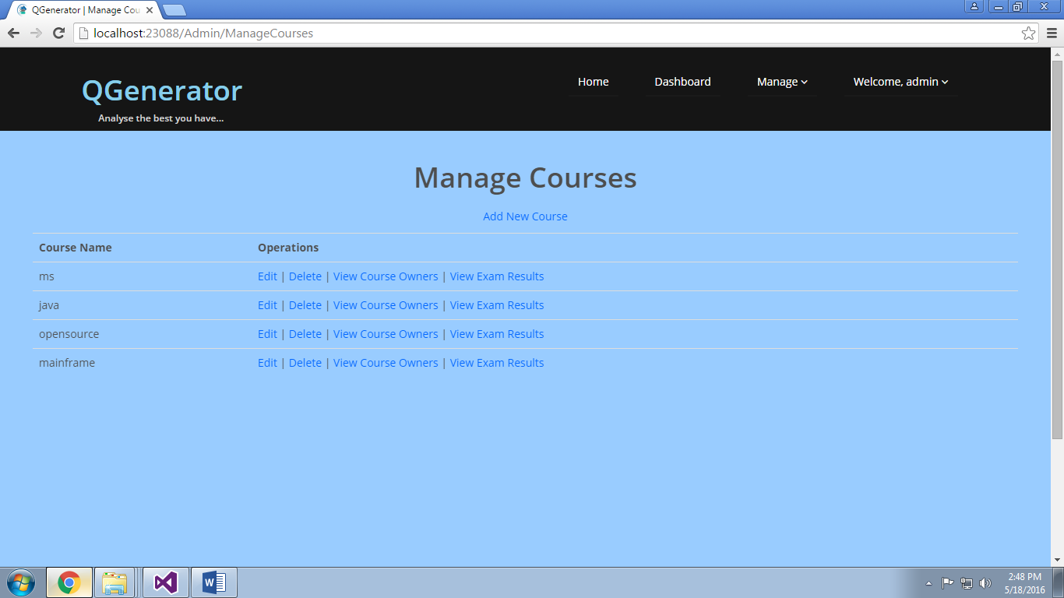

**9.15 Manage Course Owners**

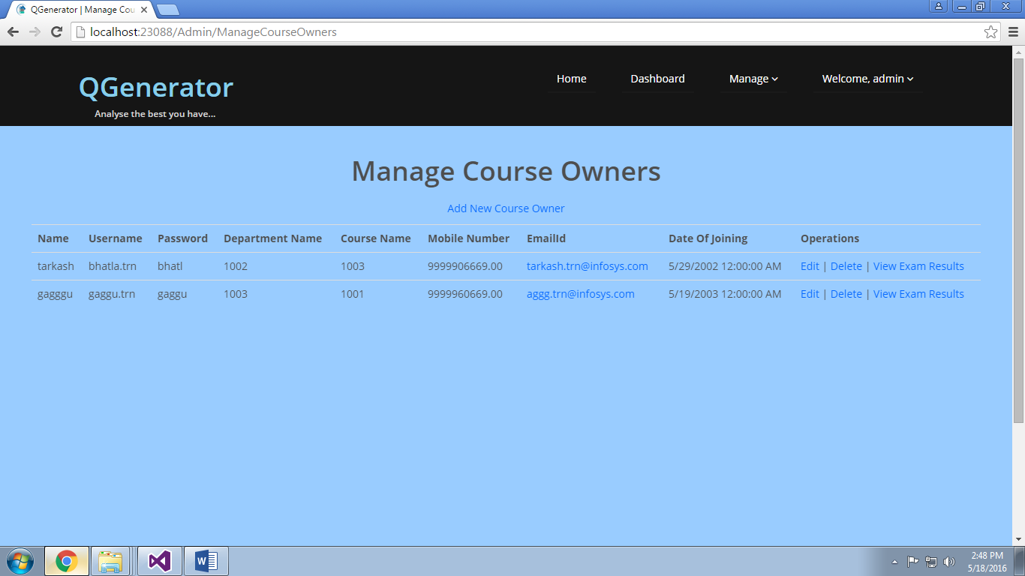

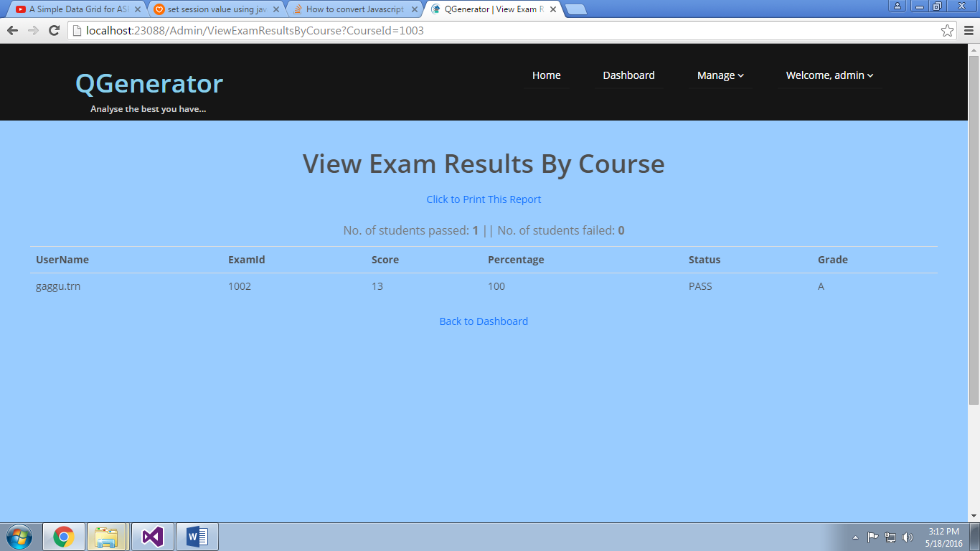

**9.16 Change Password**

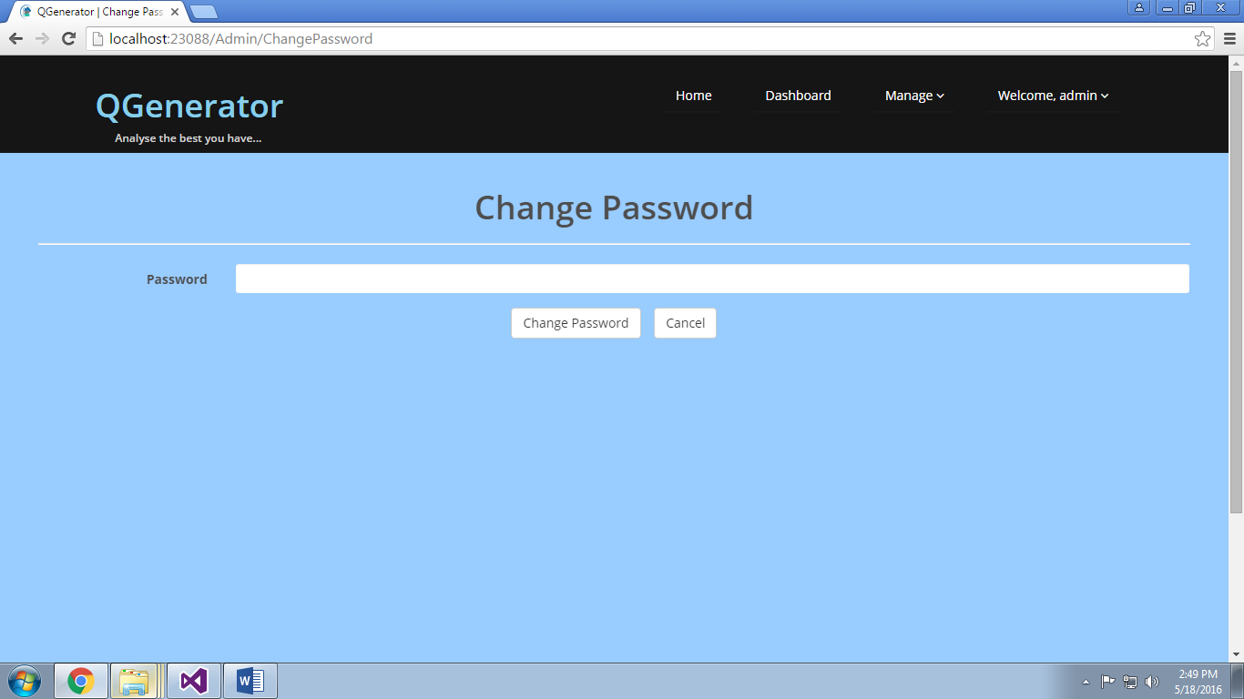

**9.17 Dashboard of Course Owner**

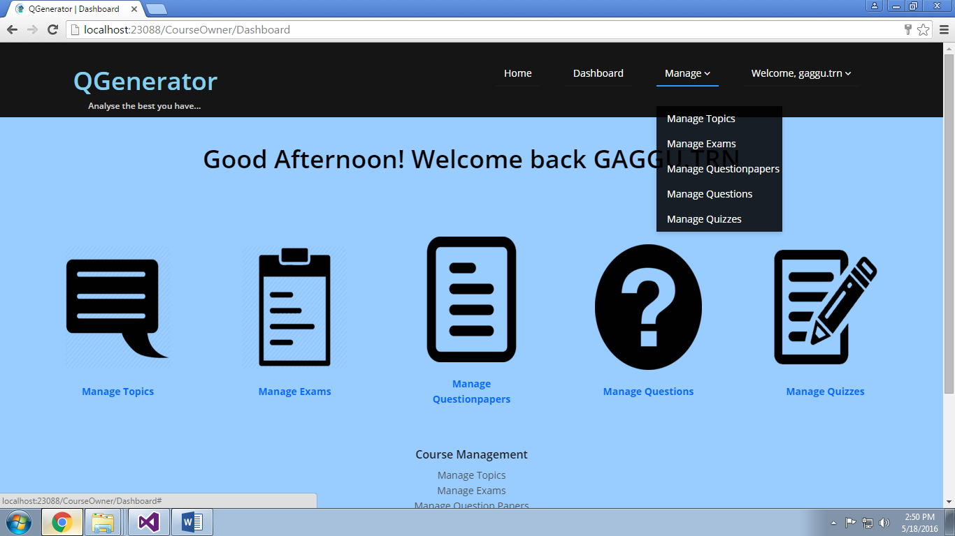

**9.18 Manage Topics**

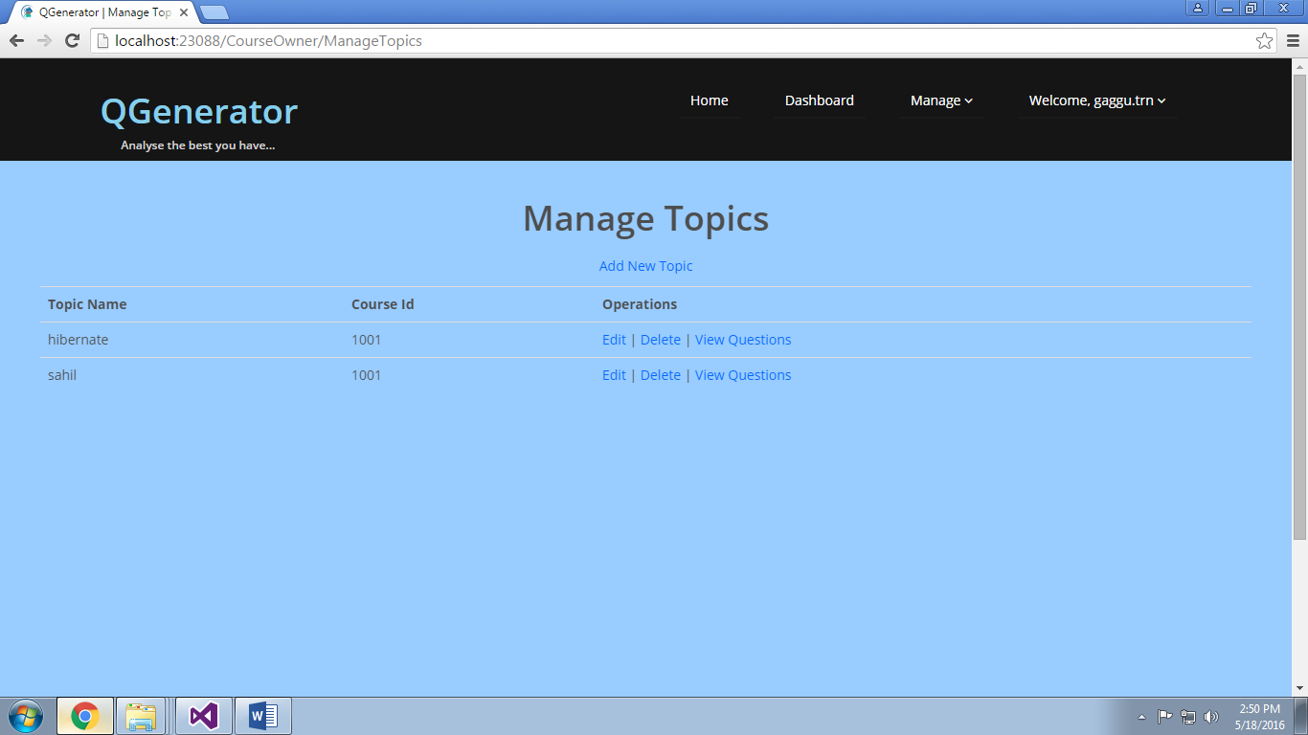

**9.19 Manage Exams**

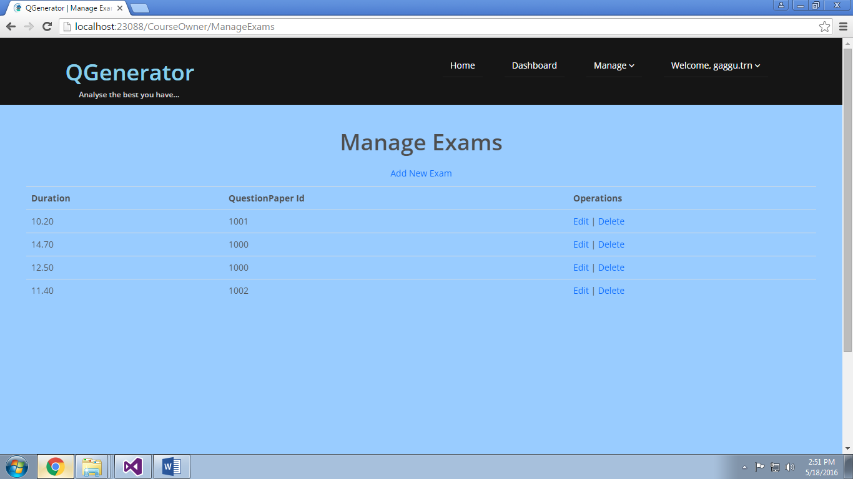

**9.20 Manage Questionpapers**

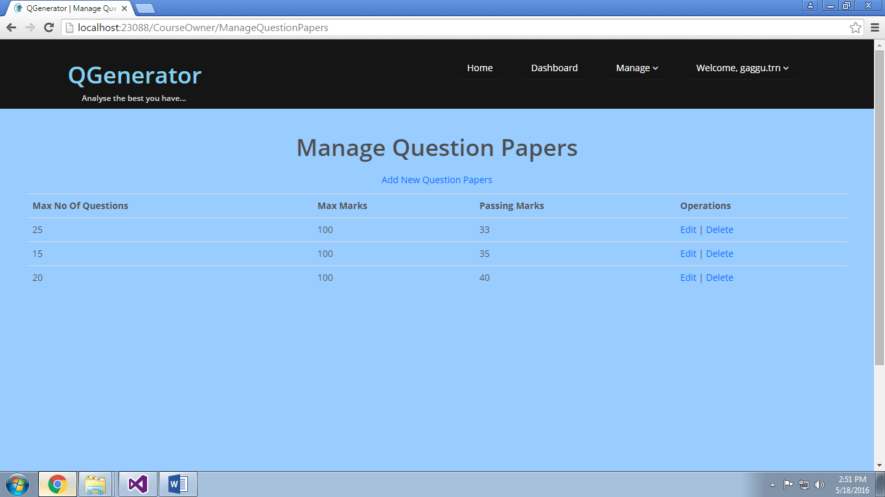

**9.21 Manage Questions**

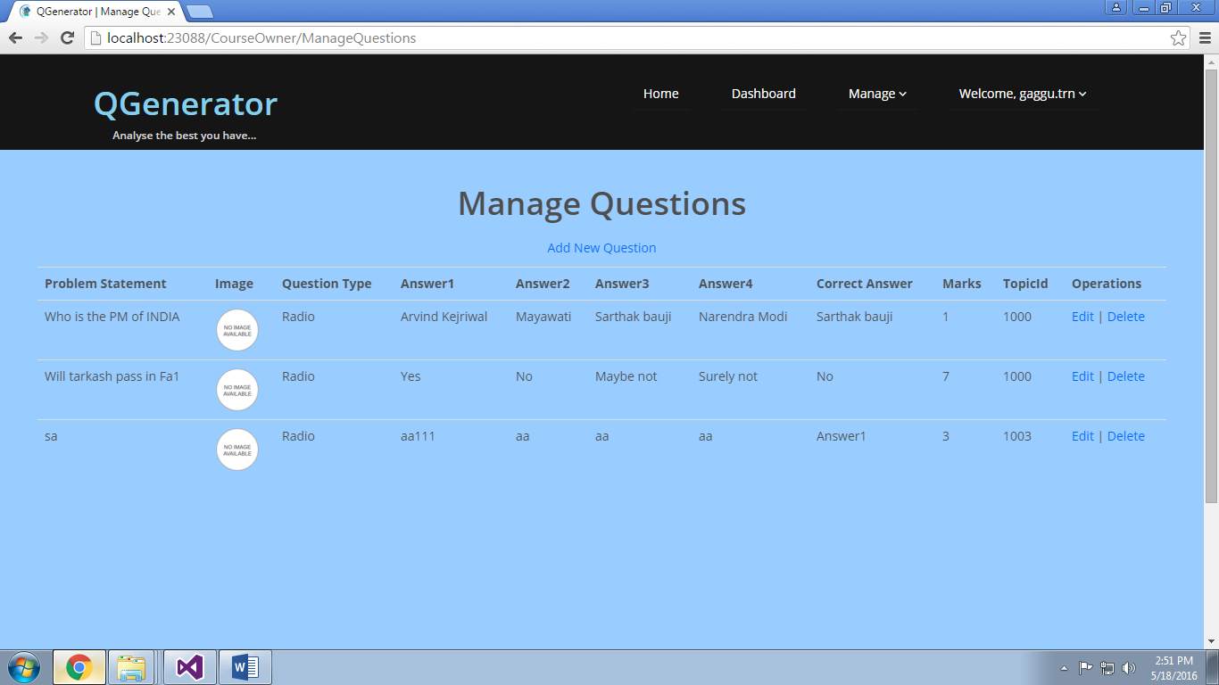

**9.22 Manage Quizzes**

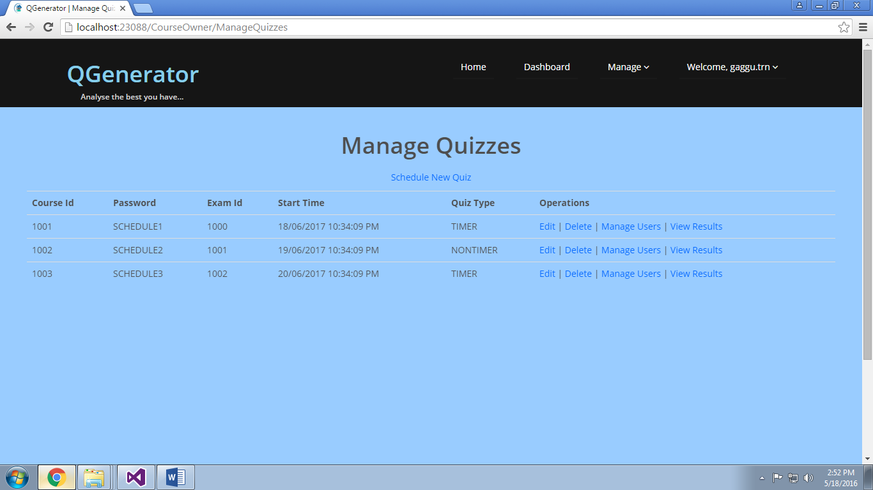

**9.23 Quizwise Result**

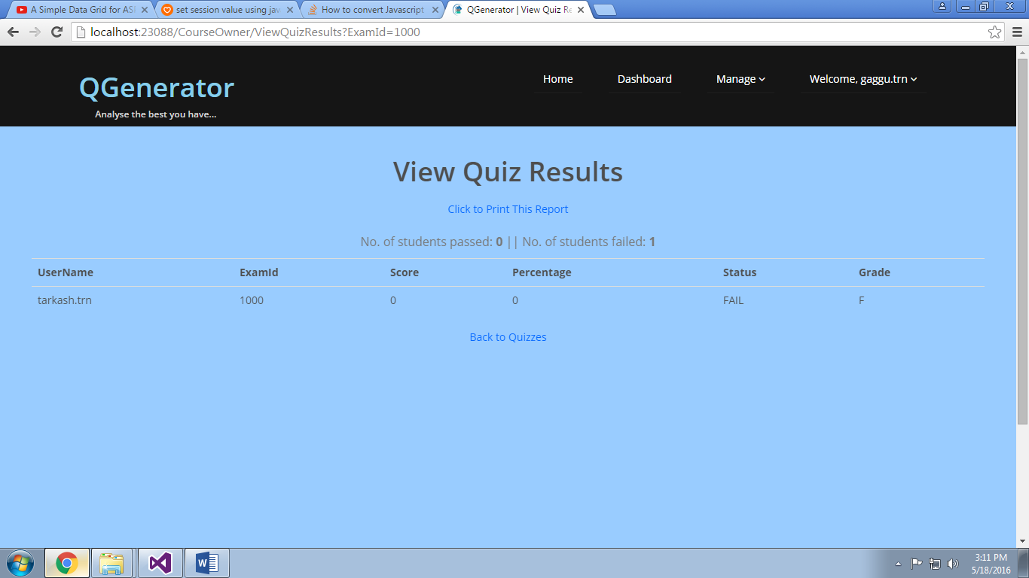

**9.24 Add Users to Quiz**

